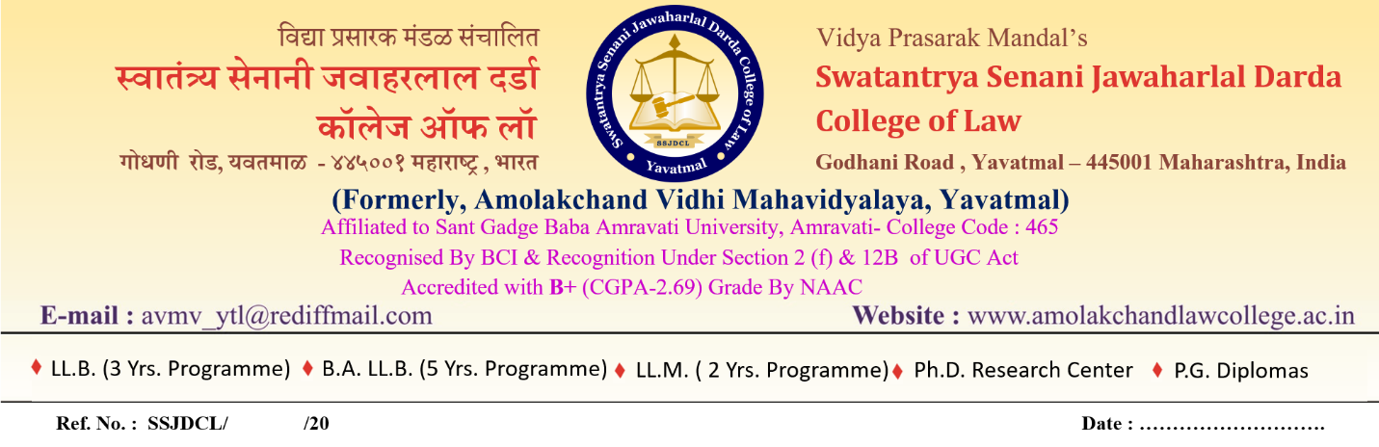

OPEN DEFENSE NOTICE

As per Deputy Registrar (Ph.D. Cell) Sant Gadge Baba Amravati University Letter No. SGBAU/Ph.D./1782/2026 Dated 25/06/2026, it is notified for general information that the open Defence of Ms. Chandni V. Ghogare for the award of Ph.D. in the subject Law in the faculty of Humanities as per the provisions of para-B-5.1 of Ordinance No.1 of 2016 is scheduled on 27/06/2026 at 11.00 am at Research Centre, Swatantrya Senani Jawaharlal Darda College of Law, Yavatmal.
Her research topic is Regulation of Noise Pollution in India –A Critical analysis with reference to Judicial Decisions. All the Teachers, Ph.D. Scholars, PG & UG Students are instructed to attend for the open Défense on the date, time and at the place mentioned above for quarries/ questions if any.

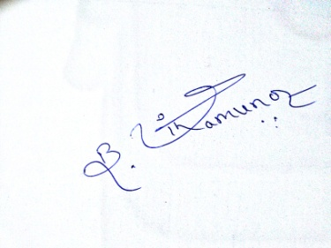
Date:25/06/2026

Principal / Head
Research Centre
Swatantrya Senani Jawaharlal Darda
College of Law, Yavatmal.

